Vaishnavi-Ketan-Tanna TY-IT-69

Experiment-03

**Aim :** To Study & DemonstrateTemperature sensor

**Objective:** 1. To understand the sensor and its working.

2. To use sensors for real time applications.

**Outcome** : Able to use Sensor board with Arduino IDE

**Theory:**

A sensor is a device that measures physical input from its environment and converts it into data that can be interpreted by either a human or a machine. Most sensors are electronic (the data is converted into electronic data), but some are more simple, such as a glass thermometer, which presents visual data. People use sensors to measure temperature, gauge distance, detect smoke, regulate pressure and a myriad of other uses.

The following is a list of different types of sensors that are commonly used in various applications. All these sensors are used for measuring one of the physical properties like Temperature, Resistance, Capacitance, Conduction, Heat Transfer etc.

1. Temperature Sensor
2. Proximity Sensor
3. Accelerometer
4. IR Sensor (Infrared Sensor)
5. Pressure Sensor
6. Light Sensor
7. Ultrasonic Sensor

There is a wide selection of temperature sensors that are used for different applications.

RTD Temperature Sensor-

RTD stands for Resistance Temperature Detector, these are more accurate and stable than other temperature sensors.As temperature changes, the resistance of any metal changes as well. This difference in resistance is what RTD temperature sensors are based on. An RTD is a resistor with well-defined resistance vs. temperature characteristics. Platinum is the most common and accurate material used to make RTDs.

Thermistors:

Thermistors are similar to RTDs in that temperature changes cause measurable resistance changes. Thermistors are usually made from a polymer or ceramic material. In most cases, thermistors are cheaper but are also less accurate than RTDs.

Thermocouples:

Thermocouples are the most commonly used type of temperature sensor. They are used in industrial, automotive, and consumer applications. Thermocouples are self-powered, require no excitation, can operate over a wide temperature range, and have quick response times.There are several types of thermocouples that are made from a variety of different materials, which allows for different temperature ranges and different sensitivities.

Semiconductor based ICs:

Semiconductor based temperature sensor ICs come in two different types: local temperature sensor and remote digital temperature sensor. Local temperature sensors are ICs that measure their own die temperature by using the physical properties of a transistor. Remote digital temperature sensors measure the temperature of an external transistor. Local temperature sensors can use either analog or digital outputs. Semiconductor based temperature sensor ICs come in two different types: local temperature sensor and remote digital temperature sensor. Local temperature sensors are ICs that measure their own die temperature by using the physical properties of a transistor. Remote digital temperature sensors measure the temperature of an external transistor.

**DHT11 Sensor:**

The **DHT11** is a commonly used **Temperature and humidity sensor that** comes with a dedicated NTC to measure temperature and an 8-bit microcontroller to output the values of temperature and humidity as serial data.

### **DHT11 Specifications**

* Operating Voltage: 3.5V to 5.5V
* Operating current: 0.3mA (measuring) 60uA (standby)
* Output: Serial data
* Temperature Range: 0°C to 50°C
* Humidity Range: 20% to 90%
* Resolution: Temperature and Humidity both are 16-bit
* Accuracy: ±1°C and ±1%

Temperature Sensor Circuit Diagram :

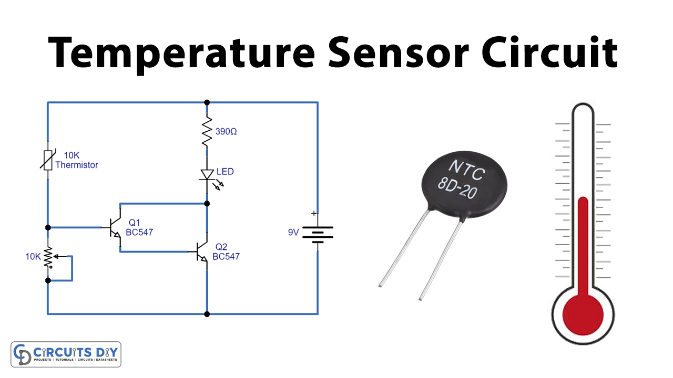

**Benefits of Sensors :**

* Accelerate processes and make them more accurate.
* Collect process and asset data in real time.
* Monitor processes and assets accurately, reliably, and continuously.
* Increase productivity and reduce total cost of ownership.
* Lower energy wastage.

From a technological point of view, the main challenges of sensor devices are related to the reduction of their cost, size, and energy consumption. Moreover, additional efforts in design and development of nanoscale sensing materials have to be made to achieve improved device performance

**Code:**

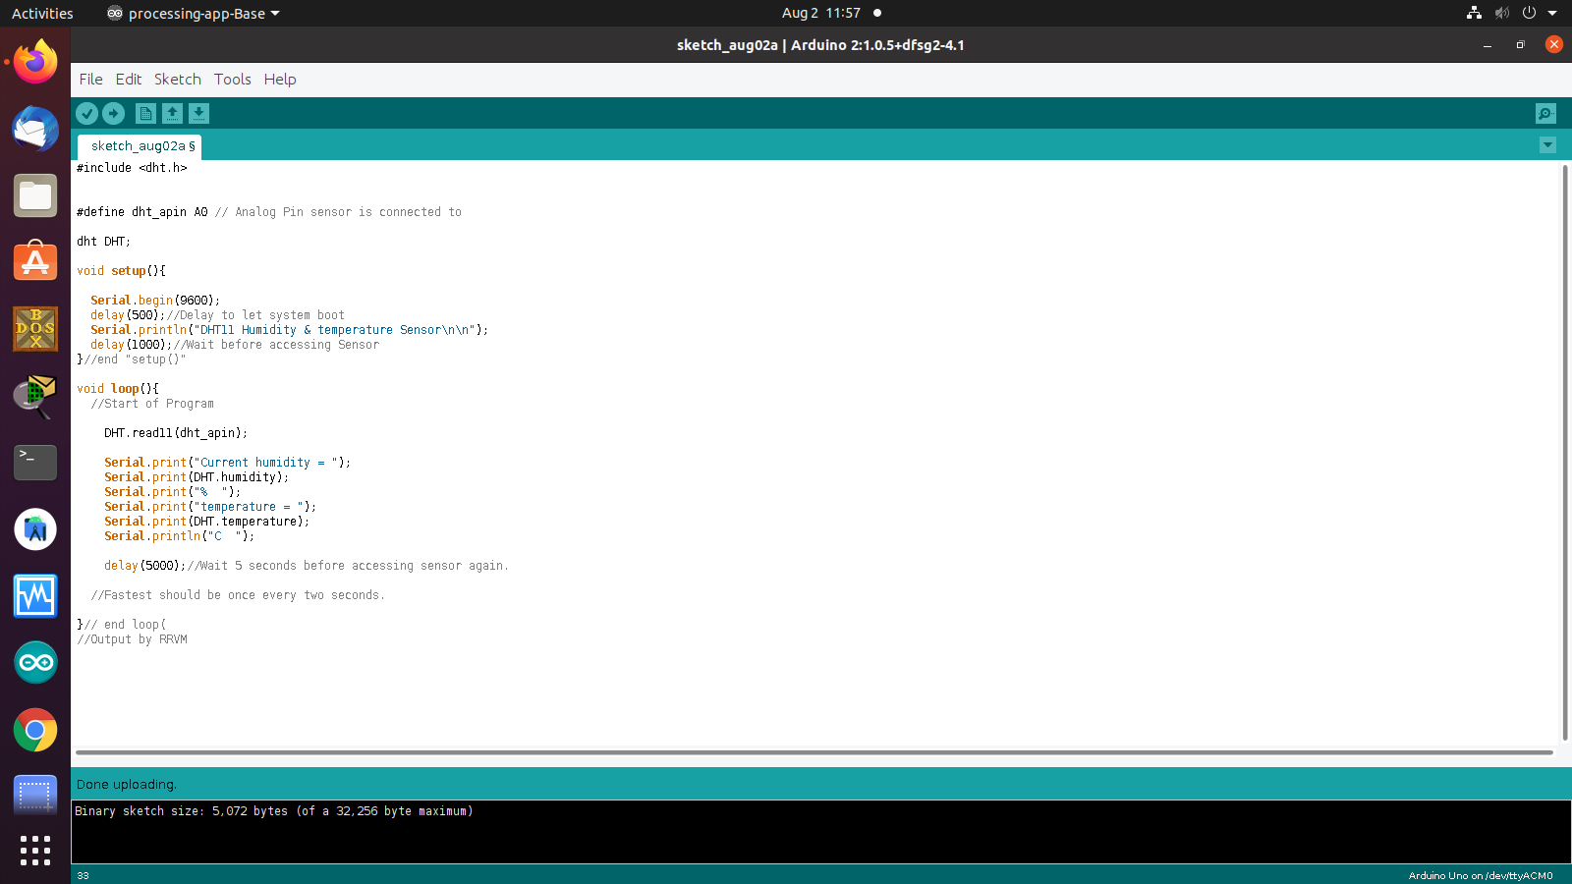

**Output:**

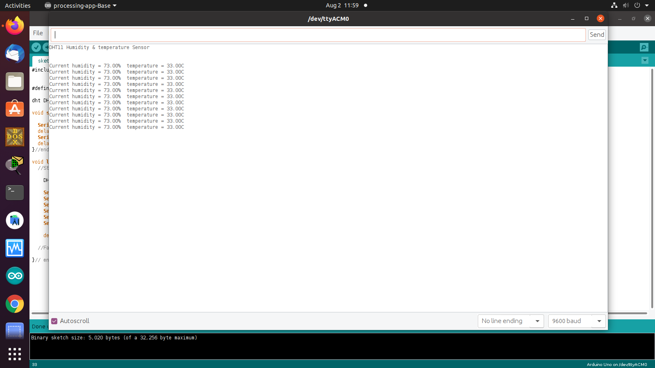

Circuit :

